1. **Download Jenkins**
2. **Configure Jenkins to Eclipse**
3. **Execute Selenium testcases using Jenkins**

-Priti Gaikar

**Part 1- Download Jenkins**

Step 1- Open your web browser and then Navigate to Below URL

“http://jenkins-ci.org “ this is the official website of Jenkins

https://updates.jenkins-ci.org/download/war/

Step 2- Now download Jenkins. War file and save

Step 3- Once download complete. Jenkins. War file that we need to execute

**Part 2-How to configure Jenkins for Selenium**

Step 1- Go to the location where Jenkins.war is available.

Step 2- Open Command prompt knows as CMD and navigate to project home directory and Start Jenkins server.

E.g. Start- cmd> Project_home_Directory> java -jar Jenkins.war

Step 3- Open Web Browser and then Navigate to below and Sign-in

<http://localhost:8080>

Step 4- Click on > Manage Jenkins



* Click on > Global Tool Configurations

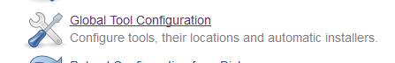

* Navigate to JDK Section And Click on Add JDK Button



* Uncheck Install Automatically check box. Give the name as JAVA_HOME and specify the JDK path.

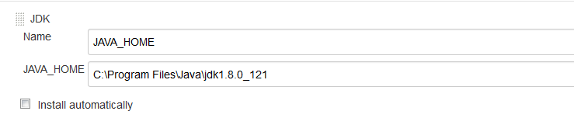

* Click on Save and Apply.



**Part 3- Execute Selenium build using Jenkins**

* Execute test cases in using Jenkins using
* Execute using Window batch command
* Open command Prompt and set the class path
* Ex. Home directory > set classpath= C:\Users\Priti\workspace\Purchase\bin; C:\Users\Priti\workspace\Purchase\libs\*;
* Open Notepad and type the below command and save as .bat file

Ex: java-cp bin; libs/*org. testng.TestNG testng.xml (“testng.xml” file will be our test suite file name)

Note: I have saved as run.bat

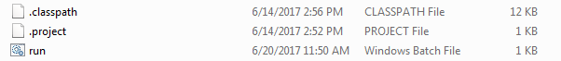

Step 1- – Create a job in Jenkins which will execute our build

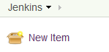

* Give the name, select Build as free-style software project and click on OK button.

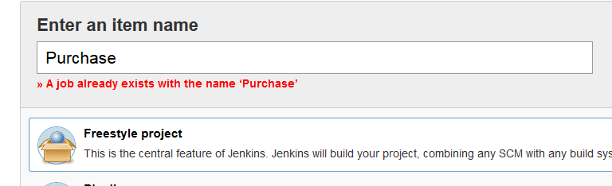

* Navigate to Advance Project Options> Check the use custom workspace > in directory we will specify the project home directory

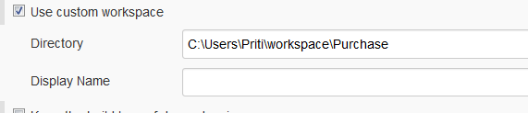

* Add Build Step > Click on Execute Window Batch command

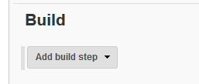

* Enter batch file name which we are created and click on Apply and save

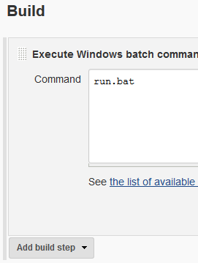

Step 2- Run the Build >Click on Build now option



Step 3- Check Build history and Console output and verify the output

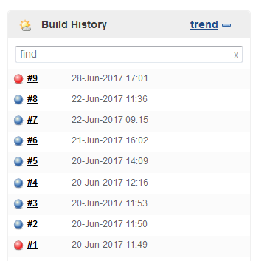

Step 4- Check Report and verify

* In Jenkins, Go to Project > Workspace > Report